Do Diabetics Require More Care
Dillon T. Isaacson
Western Governors University

David Gagner
D206
2/18/2021

Abstract
In the medical industry, a large goal is quality care to reduce the readmission rate of patients. That said, not all patient’s treatment plans are equal though they are all important. Being a diabetic, I am curious to see if there is a difference in the rate of readmission among diabetic patients compared to other patients. A step further, some common conditions with diabetes are things like being overweight, having high blood pressure, or even having hyperlipidemia (high cholesterol). Given the data set provided, I am going to investigate and see if diabetics alone are readmitted more and thus may require more or different care. Then, I may also look at diabetics with those additional conditions to see how it affects their readmission rates for hospitals.

Do Diabetics Require More Care
Part One
Finding the Right People
The question I would like to address is to find out if Diabetic patients are being readmitted at higher rates than other patients. If they are not being diabetic alone, are any common conditions that go along with being diabetic causing a higher readmission rate? The first task as with any project is to clean the data. The tools I will be relying on are Excel, R, and RStudio in this task. The data was provided in a CSV file format which makes these tools ideal in my opinion. Excel allows me to quickly see the columns, names, get a quick glimpse of the column names and what the data looks like. I also like Excel because I can quickly see any columns with NA values and know if the column has strings or number values as my approach to cleaning the data will change depending on the answer.
I chose to use R for the bulk of the work however: the actual cleaning of the data and any-and-all analysis therein. I chose R because of the flexibility for doing such things like cleaning NA values, dropping missing values, and manipulating the data to get it into a form that I want for use. Looking at the data in Excel, I found only a few columns with NA values and none with blanks so there did not appear to be any missing values. For my analysis I am only looking at a few columns within the data set concerning conditions the individuals have such as high blood pressure, diabetes, or strokes. Most of these are coded with “Yes” and “No” values, Overweight and Anxiety being the exceptions.
Having the very binary response makes this analysis an excellent choice for doing some type of categorical analysis such as ANOVA or Chi-Square. A decision tree may also be used to determine the chances of someone being readmitted, but that will be addressed later if necessary. As I mentioned in the abstract, my focus at this time is to see if anything can be determined regarding diabetic patients to see if they are readmitted at higher rates and may need changes to their care because of this.
Where cleaning the data is concerned, the data is a pretty good mix of character responses and numeric. Some of the responses are based on a scale from 1-8 so that is a numeric response that may be acting more as a factor than a true number. The data does not appear to be in too bad of condition. I did a quick check in Excel to see what columns what information and I found some interesting things. Puerto Rico cities have a 3-digit zip code, while cities in Massachusetts have a zip code that starts with a 0 so Excel drops that 0 and they appear to have only 4-digit zip codes. There are a lot of NA values in Age and Income which for my analysis will not be a big deal.
I will be using R to perform the actual data cleaning. I like R for this type of project. Specifically, in RStudio it is easy to write code and then run it in the console to see the outcome and if anything needs further adjustments. The packages I will be using are the tidyverse (dplyer mostly) and Janitor which makes quick work of cleaning up and standardizing column names. I also may use the package mosaic as that is a standard package for me to make use of, but I am not certain of that one yet.
Part Two
The Answer
For a first glance at the data, we need to know more about the readmission rates. Overall, there are 3669 patients readmitted within 30 days which is about 36.69% of the patients in total. I am going to focus solely on patients that have a readmission in the last 30 days, which is recorded as a “Yes” or “No” response. The next thing I will do is to look for any NA values, again something I can easily do in Excel to make sure I know what data type the column is as well. Using R, I have changed the NA’s in the column “Soft Drinks” to a “No” response, this was the only wrong response inside of the string-based responses, all other NA responses have been changed to a 0 for my purposes.
There are some issues in how I have chosen to clean the data. The largest is that in some instances this will create an abnormal amount of 0 values. I chose not to remove any columns because removing all the NA values would take the data set from 10,000 to around 2,300 and that is not a cut in data size that I want to make. If the set simply went down to around 8,000, I might consider that. The other issue becomes in some instances where a 0 may not make sense like someone’s age. Income CAN make sense if that person is a dependent of someone else, they may not have an income themselves. Age however will never be 0, for kids they record age by months for the first two years of life or so. If I were using Age as a factor in my analysis, I would likely drop the rows with a 0 as those would all be considered an outlier and not valuable to my analysis. I am choosing not to look at that for my analysis so I can disregard those outliers.
I narrowed down my data set to the following columns: Readmission, High Blood Pressure, Stroke, Complication Risk, Overweight, Arthritis, Diabetes, Hyperlipidemia, Back Pain, Anxiety, Allergies, Acid Reflux, and Asthma. I did simply some names here to help convey meaning, but the essence is the same. I also took the time to code them, so I had a numeric response and a factored response for each of these and then I filtered it down so the only people I was looking at were those who were readmitted within 30 days as that is a large focus of this analysis. Looking at this new data set for a Principal Component Analysis, I found that all of the variance in the data could be described by the following columns: Overweight, Anxiety, High Blood Pressure, Stroke, Complication Risk, Arthritis, and Diabetes. Of these, diabetic patients explained the least amount of variance in the data. However, they still did explain some of it and help to complete the picture. These components when analyzed all have a standard deviation above 1, as seen in Figure 1 below. This means they have a meaningful contribution to the variance in the data.
Figure 1
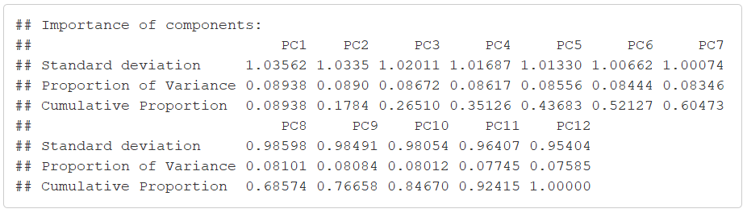
Knowing that, it appears that Diabetic patients, along with the others listed, do need revised on their treatment. What is interesting to me is some of these such as being overweight and having high blood pressure are closely related to being diabetic. Having these conditions all account for a portion of the variance in the data means I would suggest hospitals do a revision of how they handle care for those patients. It would be worth looking into what the current common practices are and seeing if any single facility has a lower readmission rate for these conditions and looking at what their practices may be in order to try and help other hospitals reduce their readmission rate and fix their ERD percentages.
Another to look at these numbers is through a screeplot. Figure 2 shows the screeplot as a quick visual representation of the numbers highlighed above. I’ve added a line at 1 to highlight the first seven components as being significant. I listed them above, and the component I was most concerned about for my question was Diabetic patients and they are number 7. Looking at the plot in Figure 2, it is clear that although it is a close cut the Diabetic patients do appear to be a significant component.
Figure 2
